*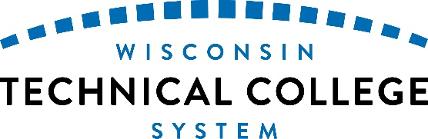****HEAB: WTCS Wisconsin Grants***

2025-27 Biennial Budget Initiative

**Issue: Wisconsin Grants - Technical Colleges – *Meeting the Need of Wisconsin Technical College Students***

Wisconsin Grants, the state’s largest needs-based financial aid program, provides students with the necessary assistance to pursue a higher education credential with the objective of entering or improving their career in the workforce. During the 2023-24 Fiscal Year (FY), the Wisconsin Technical College System (WTCS) experienced the first waiting list in over ten years and is projecting a larger waitlist for the 2024-25 FY due to an increase in student need.

**Background**

For the most recent FY, the Higher Educational Aids Board (HEAB), the state agency responsible for administering financial aid, determined WTCS expended all the appropriated funds for FY 2023-24, used $3 million from the next FY to cover all student committed awards and had a waitlist of 3,200 students. Students who received a grant during the academic year had a higher calculated need than in previous FYs, which resulted in more students receiving larger grant award amounts. Put simply, WTCS student financial needs have and will continue to increase.

In addition to the current waitlist, WTCS is projecting the waitlist to grow significantly in FY 2024-25 due to changes in the federal formula for determining a student’s financial need. WTCS projects an increase of $4.4 million will be needed to cover increased award amounts for current students and new awards for students who will become eligible as a result of using the new federal methodology.

WTCS, Wisconsin’s largest higher education system, provides education and training to non-traditional and an underserved student population that has higher financial need than the other higher education sectors in the state. As shown in the chart below, a WTCS student has a higher unmet need as compared to the average unmet need of a UW student.

Over that same period of time, the Wisconsin Grants appropriation for all three major higher education sectors in the state received only one increase in continuing funding for the program. WTCS received an increase from $18.8 million to $23 million (22% as shown below) in fiscal year 2017-18.

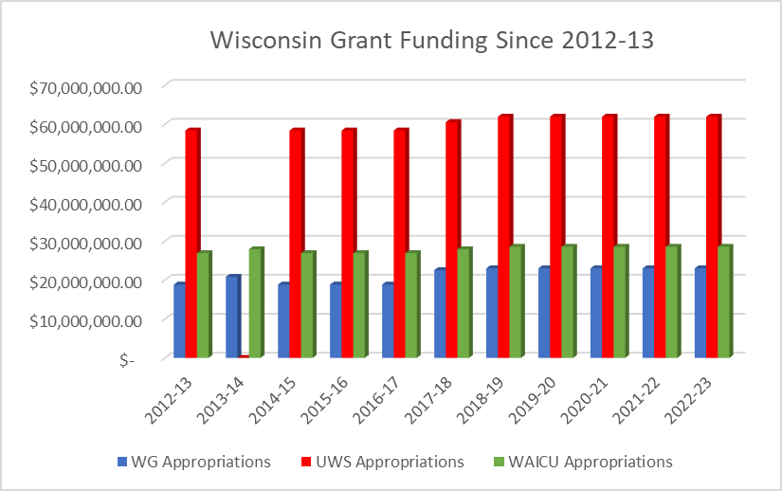

*Note: UWS received $0 in fiscal year 2013-14*

While the unmet need continues to rise, state investments in Wisconsin Grants has not kept up with the rising costs for students. Between 2012-13 and 2022-23, the average WTCS student financial need increased from $10,400 to $15,500, an increase of 37%, which outpaces the one-time increase received over the last ten years as shown in the chart below. As WTCS enrollments continue to increase, student need has also increased significantly, which is the determining factor for why WTCS has expended all Wisconsin Grants funding in the most recent academic year.

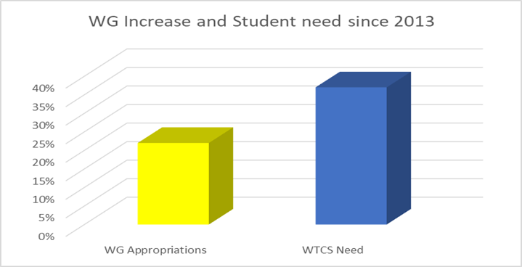

WTCS student need is not limited to those who have the highest need or qualify for a maximum grant award. As shown in the chart on the following page, 72% of the 58,000 students who applied for financial aid qualify for a Wisconsin Grant.

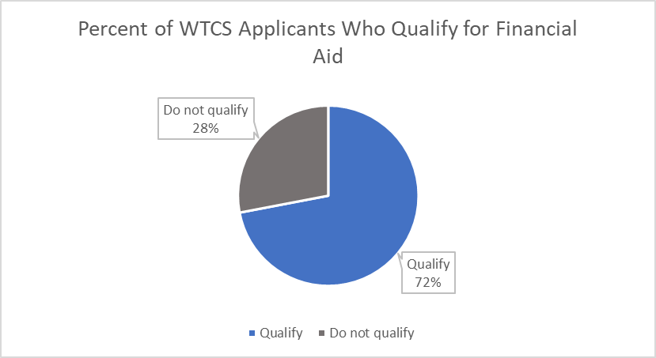

Historically, WTCS students have had the highest need compared to the other major higher education sectors in the state. As outlined in the graph below, close to 50% of WTCS students who apply for financial aid are identified as having the highest financial need and qualify for the maximum award. This means 28,000 out of the 58,000 individuals who completed a FAFSA and selected a technical college as their first choice would have $0 to contribute to their college education.

It is imperative the state continues to invest in WTCS students to ensure WTCS has the ability to provide quality education and training to all who are willing and able to gain a credential so they may enter the workforce.

# Request

**$10.8 million in each year of the biennium to meet the projected waitlist of students and to meet the increase in award amounts based on the rising financial need of WTCS students.**